

Mohammad Ali Jinnah University

Chartered by Government of Sindh - Recognized by HEC

**Quiz 2**

**Name:** Muhamad Fahad

**Id:** FA19-BSSE-0014

**Subject:** [Linear Algebra (Fall 2020)](https://classroom.google.com/u/0/c/MTgxNTU3ODEwMjQw)

**Section:** AM

**Teacher:** Dr. Asmat Ara

**Date**: Wednesday, November 4, 2020

##### Linear Algebra

**Quiz#2**

###### Instructor Name: Dr. Asmat Ara Total Marks: 10

#### Date: 4-11-2020 Time:

# 

Q.1 Find the inverse of the following matrix.

Z=

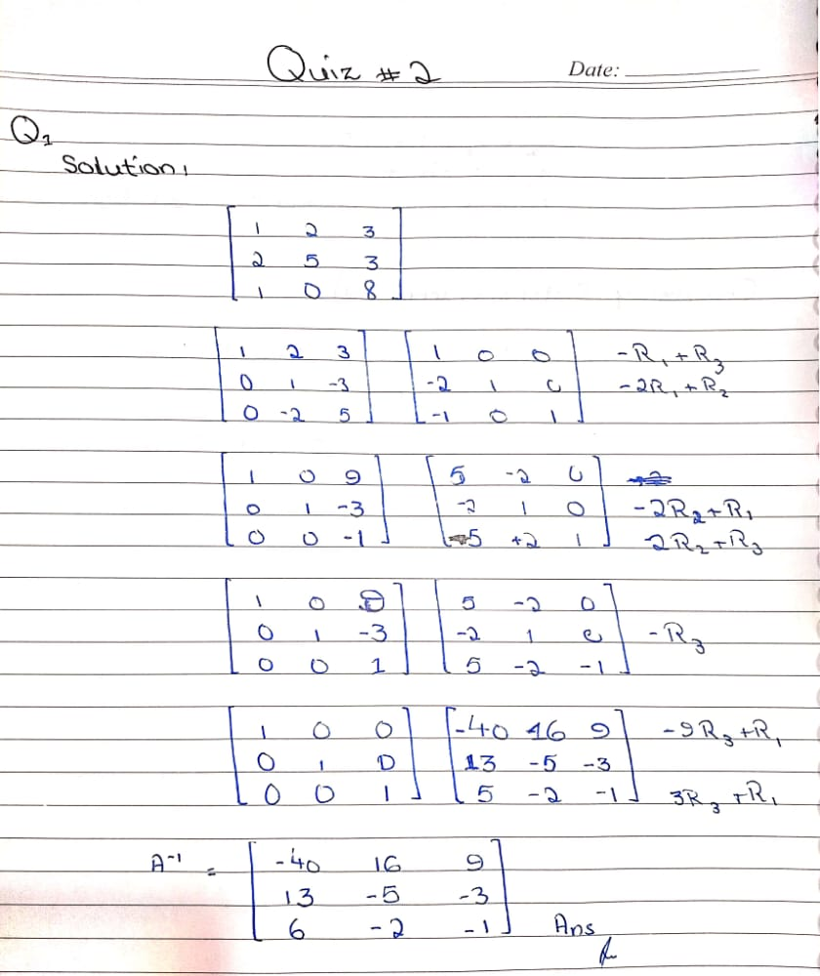

Q.2 Evaluate rank and nullity of the following matrix

